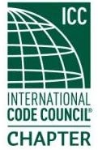
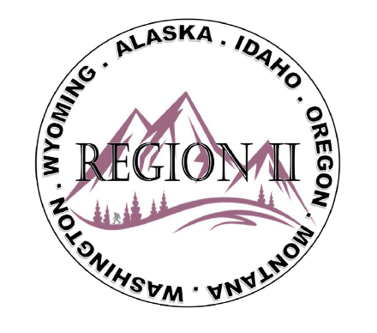
ICC Region II Business Meeting
January 14, 2026
10:00-11:00 A.M PST
- President call meeting to order, Roll Call of R2 Board Members (verify quorum)
- Approval of previous meeting minutes, November 12th. Motion required.
- Treasurer’s report, Breck Cook. Acceptance of Treasurer’s Report. Motion required.
- BOD Liaison Ron Clements with ICC Update, and comments
- Other ICC BOD members acknowledged and provide updates
- ICC Government Relations Liaison – Bryan Imai
- Guest Speaker -Chemeketa Foundation Director of Development – Jamie Wenigmann,
- Guest Speaker - ICC Manager Next Generation Training – Alex Kerr
- Upcoming Trainings:
AI Webinar Class on 2/17/26 with Ed Cilurso – ICC Innovation Team Manager
OPTA “The Complete Permit Technician" February 3 - 5, 2026
- 2026 Chapter Leadership Academy April 17–18, 2026 | Hartford, CT
- Discussion on changing from Citizens Community Bank to First Interstate Bank
- Regional Updates – Alaska, Washington, Wyoming, Oregon, Montana, Idaho
- Comments for the good of the order
- Discussion items for next meeting – website updates and R2 committee members
- Next meeting February 11, 2026, 10:00am – 11:00am PST
- Adjournment. Motion required.

