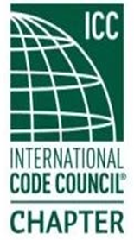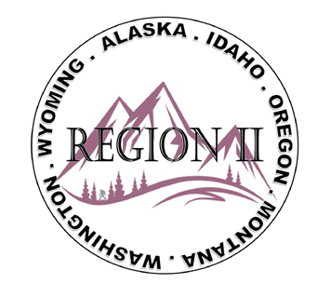

ICC Region II Minutes
August 12, 2026 10am – 11am PST
- Call to order at _10:02_am, confirmed quorum.
- Roll call of board and introductions.
- Motion made and approved of submitted minutes from July 2025
- Treasures report – Balance $_37,917.05_ (donation of $20,000)
- Ron Clements – (1) Committee Calls, check out webpage, lots of open seats (2) Energy conservation code being split into 2 (3) Voter validation (4) ICC Bylaw change vote at ABM in Nashville (5) CDP Access clean up (6) Jack Applegate gave away riffle in Wyoming ABM
- Bryan Imai – (1) Expansion of the region membership (2) CDP access building code development can be licensed for internal code development (3) 2027 codes are expected to be out end of year (4) IFC Battery update / guide check ICC Website
- Director Jessica Fust – Absent
- Director Jim Sayers – Absent
- Director Jack Applegate – Committee call can be a building or fire official or staff from a jurisdiction.
- Director Andy Higgins – (1) Update from CEO Belcik that the registration is filling up quickly with high demand for the conference. (2) Wyoming was a great event
- President Mike Boso – Absent
- Director Steve McDaniel – Possible ICC CEO and President Midwest tour to chapters.
- Director Sam Palmer – (1) Update from Region 1 on training update in the area. (2) Look at Palisades California on fire recovery information.
- Regional updates
WASHTINGTON:
(1) WSAPT has registration open for training for permit techs Sept 22-23. (2) WABO 2026 fall business meeting oct 29-30 (3) WABO executive meeting 8/13/2026 (4) Spokane needs assistance with after the fire recovery

MONTANA:
- Comment stage for 2024 codes is open, expect to be adopted in Sept. (2) March 8-12, 2027, annual ABM to be in Billings
IDAHO: No updates
WYOMING: No updates

OREGON:
- OPTA has virtual class for the complete permit tech on Sept 15-17, cost is $200 for 10 hr. web class. Call for discount code to get out of state rate. (2) Southern Oregon chapter meeting next week Thursday/Friday. Seafood boil is on Thursday. November training 2024 IBC Essentials (3) Eastern Oregon ABM coming up. Dec 4 training When Disaster Strikes.
Alaska:
- State of Alaska possible 2024 code adoption late 2026 / early 2027. (2) Anchorage adopted single exit buildings. (3) Job openings at State of Alaska Fire Marshal’s office for plan reviews and investigators (4) Alaska Central Chapter annual business meeting will be tentatively January 13 during the State of Alaska Fire Marshal’s Forum happening January 12-14, 2027, in Anchorage.

- Miscellaneous Region 2 items
ABM Nashville may still have 3 rooms left throughout the regional organization.
R2 Rafflel is online on the Website for $25 each or 2 for $40. $1800 fishing rod package.
Sean Collier from WY and Dave Jahn from OR in Region 2 were awarded ABM leadership shadow
Scholarships only 4 people have applied – Need to apply (registration to ABM plus $1000)
7 ICC Board members attended the Wyoming 50th Anniversary
- Next meeting, September 9, 2026. Motion and approved to Adjourn.
ATTENDEES:
Region 2 officers
Absent - Cache Olson (Immediate Past President) – excused -
Present - Ted Zuk (Region 2 President)
Present - Bret Caulder (Vice-President)
Present - Breck Cook (Treasure)
Present - Bart Meinhardt (Secretary)
Present - Tim Blevins (Director 1)
Present - Amy Williams (Director 2)
Present - Holly Carothers (Director 3)
Present - Ben Abbey (Director 4)
Guest
Lucas Sobeck, Devon Linebaugh, Bret Stoddard, Ron Clements, Bryan Imai, Jack Applegate, C.Nunley, Serena Locke, Andy Higgins, Kelly Thompson, Brian Dorland, Sam Zohorka, Quyen Thai, Adele Schaffield, Andie Lorenz, Melany Klemmer, Ray C, Steve McDaniel, Hoyt Jeter, Derrick Moon, Sam Palmer, Elizabeth Torske, Katherine Denight, Christiane Reed

