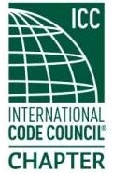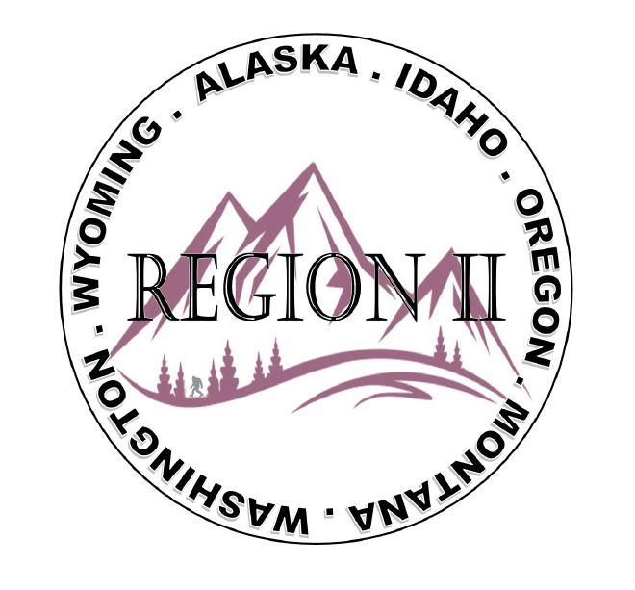
ICC Region 2 Business Meeting MINUTES April 10th 2024 10:00-11:00 PST
- President Olson called meeting to order at 10:05 PST. Roll call: President-Cache Olson, Vice President-Ted Zuk, Treasurer-Bret Caulder not present, Secretary - Breck Cook Past President- Andie Lorenz not present, Directors-Tim Blevins; Chad Wiltrout; Joe Fisher; Bart Meinhardt -Total of 25 participants
- Introduction of Region 2 Board, announcements. President Olson provided general updates.
- Acceptance of previous meeting minutes, March 13th, 2. 023 Motion required. M- Tim Blevins, S-Bart Meinhardt, Motion approved.
- Treasurer’s report -Holly Carothers. Motion required. M- Ted Zuk, S- Joe Fisher, Motion approved
- BOD Liaison and ICC Update, and comments – ICC Board member Jim Sayers was on the call and provided ICC updates and a reminder about the importance of Building safety proclamations. Jim also spoke about the ICC 30th anniversary and how that will affect the ABM in Long Beach. Jim also talked about the search for a new ICC CEO to replace Dominic Simms who is retiring at the end of the year. Also mentioned was ICC would like to have 3000 attendees at the AMB in Long Beach. There was a question from the membership regarding the Code of Honor scholarship which Jim made clear would not be available until the ABM in 2026. There is however the ICC leadership experience available. Submit application by June 15 2024
- ICC Government Relations Liaison – Kraig Stevenson spoke about the importance of submitting Building safety month proclamations. Will send info once available for ICC Leadership experience program and confirm any deadline. Jim Sayers spoke up “ one last thing” warning all on the call about counterfeit code books circulating.
- Committee Reports. Bylaws-no report, Budget-previously reported, Code Dev- Ted Zuk discussed possibly collaborating with Northern Calif. and Washington Chapters. Awards/Nominations-no report, Military Family-Previously updated by Jack, Breck will send an interest email to membership regarding potential scholarship candidates. Membership-no report, Education-no report.
- Old Business- Discussion regarding Region II Chapter present fundraising – training - Raffle tickets for guided fishing trip in Montana? Cost for Travel? Travel will not be covered. Raffle tickets to be sold at ABM in Long Beach.

- Regional Updates – Wyoming, Montana, Idaho, Oregon, Washington, Alaska. Regional Educational opportunities have been added to R II website.

- Comment for the good of the order. None.
- Next meeting May 8th, 2024 at 10:00 AM PST.
- Adjournment. (11:34 AM PST) Motion required. M-Steve Matiaco, S-Adele Schaffeld, Motion approved.

