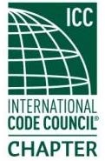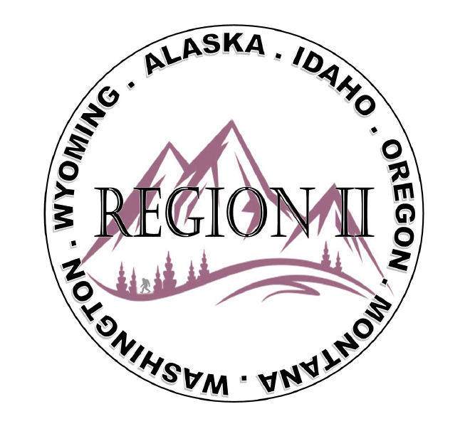
ICC Region 2 Annual Business Meeting
Huntington Convention Center - Cleveland
October 19th 2025 - 3:30-4:30 PM EST

- President call meeting to order
Note that ICC Board candidates will be periodic during meeting limited to a few minutes each
- Roll call / Introduction of R2 Board members and declare a quorum
- Roll call / self-introductions of membership present
- President’s Opening Comments
- Acceptance of Previous Minutes, Sept 10th – Motion required
- Treasurers Report – Bret Caulder – Motion required for acceptance of treasurer’s report
- Government Relations Liaison Report – Byran Imai
- Raffle update – winner at tomorrow’s mixer – Last chance to buy a ticket
- Mixer update / reminder – Nuevo Lakeside, 1000 E. 9th Street on the Pier - 7PM-9PM
- Sponsor acknowledgement – Safebuilt, NW code professionals, 4-Leaf, Central Alaska Chapter ICC
- Regional Updates – Wyoming, Montana, Alaska, Idaho, Washington, Oregon
- President’s recognition of membership – President’s awards – President Olson
- Election of Region II Board of Directors – Call for Nominations
- Swearing in of new Region II Board – Jim Sayers
- Region II Photo taken of entire group present
- Open Discussion
- President’s closing remarks
- Next meeting will be zoom November 12th at 10:00 PST
- Call for adjournment – Motion required

