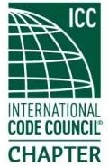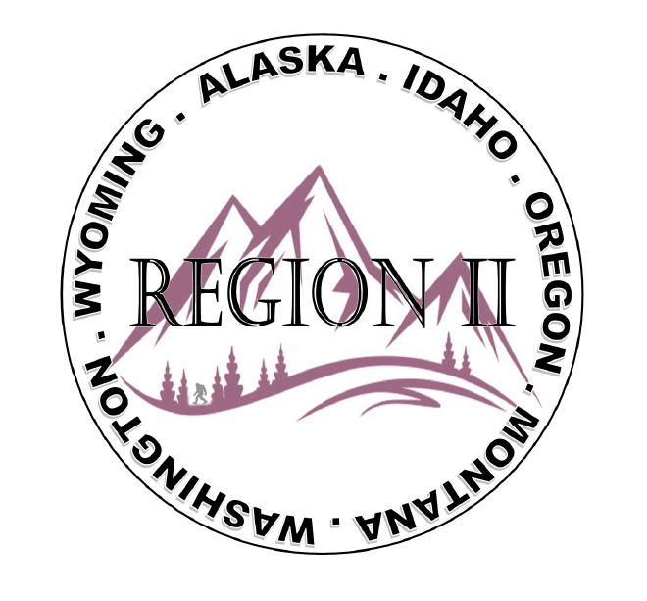
ICC Region 2 Business Meeting MINUTES September 11th 2024 10:00-11:00 PST
- President Olson called meeting to order at 10:04 PST. Roll call: President-Cache Olson, Vice President-Ted Zuk excused absent for another meeting, Treasurer-Bret Caulder – joined meeting a little late, Secretary - Breck Cook, Past President- Andie Lorenz, Directors-Tim Blevins; Chad Wiltrout; Joe Fisher; Bart Meinhardt. ICC Board , Dave spencer, Jack Applegate, Jim Sayers, ICC Gov Relations, Bryan Imai, Attendees: Brian Dorland WA, Jon Laux, ID, Sam Steele, Seattle, Serena Locke OR, Melany Klemer OR, Holly Carothers OR, Tela Gardner WA, Katherine Denight OR, Lucas Sobeck MT, Sean Collier WY – attended a little late

- Acceptance of previous meeting minutes, August 14th, 2. 024 Motion required. Jim Sayers corrected a spelling error, M- Bart Meinhardt, S- Tim Blevins, Motion approved.
- Treasurer’s report -Bret Caulder not present yet, Holly gave the report. One expense at #35.00 and balance of $9986.10. Motion required. M- Jim Sayers, S- Serena Locke, Motion approved
- President Olson asked for update on raffle. Holly gave update, flyers made, QR code in place, $15 apiece, Trip includes stipend of $500, second prize $150 Cabela’s, third prize $100.00 Cabela’s. Breck commented that tickets easy to buy and encouraged promoting them.
- President Olson reminded the upcoming elections at the ABM. Discussion on open seats, Director at Large seats #1 and 3. Bart and Joe’s seats up for renewal. Holly may run from the floor.

- BOD Liaison and ICC Update, and comments:

Jim Sayers – ICC Board meetings at the ABM , very busy. A lot of committee meetings going on. Many candidate forums last several weeks and upcoming. John Belcik new CEOI shadowing Dominic.
Jack Applegate – Send staff to ABM, very important. Come see Dave sworn in as President. Race for sec/ treas. Board to meet on federal copyright case. Energy code development process ongoing.
Dave Spencer – Biggest ABM ever. A lot of new trainings, meetings. Pick before hand because there are a lot. Has a great speech in store for us. Find someone to take with you there and mentor.
Bryan Imai – Introduced himself as new Gov relations person.20 years as general counsel to WA Auto dealers Assoc. Lot’s of legislative experience. Meeting everyone from the chapters in next few weeks.

- Regional Updates:
Wyoming – Sean Collier – State code updates switching to 2024 code. Fall BM is Nov 13, 14, 15th. Banquet on the 15th. Will share for listing on R2 website.
Montana – Lucas Sobeck – Rebuilding the big sky Chapter ongoing and getting back on track.
Idaho – Bret Caulder – ID board meeting on IFC and lithium batteries still in progress. Encouraged mentoring someone to the ICC ABM. New director in Nampa didn’t know but now may be going. Tell others.
Oregon – Breck Cook – SOC-ICC meeting next week. Sending 4 SOC members to the ICC-ABM. Having ORSAP training Nov 21st.
Katherine Denight – EOBO – 2nd ABM Oct 10th and 11th. Getting inducted as official at ICC ABM. Will offer trainings when a full chapter with benefits. Register through OPTA website.
Chad Wiltrout – OBOA Fall Educational event sept 24th – 26th
Serena Locke – OPTA ABM Nov 6-8th. Permit tech class, why codes important, prefab and modular construction. Sorenson teaching – two days. Chapter 3 plan review class. PTN – Day of service Saturday, ABM meeting Sunday at 10 AM.
Tela Gardner – WSAPT – Sept 20 Ed class with Steve burger – toning down the hamster wheel. Favorite instructor. Also Bluebeam class. Sending 4 people to ICC ABM.
Sam Steele – New chapter president – Gabriel Barron. Lot of energy and representing at code hearings.
Tim Blevins – WABO -Oct 17-18th – Fall QBM at Heathman’s in Vancouver. Western WA Chapter is Oct 10th in Tacoma.
Bart Meinhardt – S Alaska chapter – Construction slowing down – gets 0 – 20 degrees. Planning on doing 3-5 classes in early winter. Sending 7 people to the ICC ABM. Involved with the Fire Chief Assoc in Dallas on Lithium batteries.
Joe Fisher – sending entire Kenai department to ICC ABM. Look forward to seeing everyone.

- President Olson spoke of the President’s award to be given out at the ABM. Too many choices. Will be more than one individual.
.
- Jim Sayers commended Alaska for sending so many folks to the ICC ABM.
Open Discussion ended. President olson asked for motion to adjourn.
- M- Jon Laux S Joe Fisher Motion so moved.
- Next meeting at Long Beach Oct 20th

- Next meeting Sunday October 20th, 2024 at 3:30 PM PST. Long Beach Ca.
- Adjournment. (11:23 AM PST) Motion required. M-Jack Applegate, S-Jim Sayers, Motion approved.

