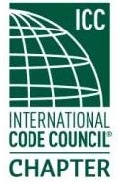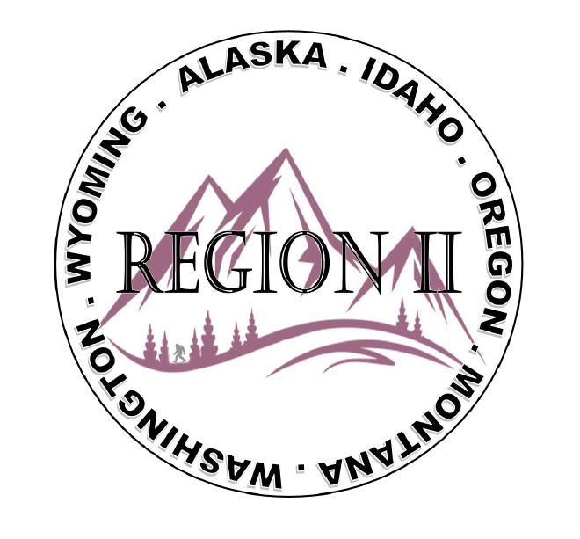
ICC Region 2 Business Meeting
April 10th 2024
10:00-11:00 PST
- President call meeting to order, introduction of guests, roll call.
- Introduction of Region 2 Board, roll call, announcements.
- Acceptance of previous meeting minutes, March 13th 2. 024, Motion required.
- Treasurer’s report, Bret Caulder. Motion required.
- BOD Liaison and ICC Update, and comments – Jim Sayers, other BOD Members.
- ICC Government Relations Liaison – Kraig Stevenson.
- Call to Committee updates
- Old Business- How to use the Benefit training proceeds for military families.

9. How to handle Travel Costs for Ben Abbey fishing Trip
10. Will there be scholarships for ABM in October.
11. Fundraising Ideas
12. Regional Updates – Wyoming, Montana, Idaho, Oregon, Washington,
13. President’s comments, recognition of Region 2 members.
14. Comment for the good of the order.
15. Next meeting May 8th 2024, 10:00-11:00 AM PST.
16. Adjournment. Motion required.

