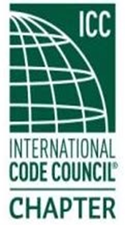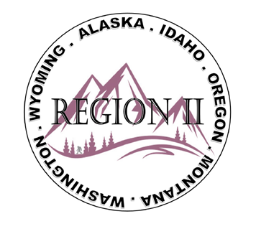

ICC Region II Minutes
November 12, 2025 10am – 11am PST
- Call to order at 10:01am, confirmed quorum.
- Roll call of board and introductions.
- Motion made and approved of submitted minutes from October 2025
- Ron Clements – R2 ICC’s Liaison. BIRC Deep Dive: https://www.iccsafe.org/committees/birc/; Open committee calls, Pro Codes Act – encourage everyone to individually submit. Emory Rogers Scholarship submissions close December 17; AI Navigator is 95% code correct.
ICC annual meeting in Hartford Connecticut April 19-28, 2026. Public Comment Hearings Group A and B expected to last 4-5 days, about 100 comments Group A and 150 Group B.
- Bryan Imai - The Code Council is currently seeking volunteers for 2027-2029 Cycle Committees to help support the development of the 2030 International Codes (I-Codes). (See BSJ Article: CACs & CSC, CDCs, CICs and CCC) Click on the "Apply" tab for information on how you can apply. The 2027-2029 schedule is available here.
- Jessica Fust – Director of ICC Board of Directors, Alternate Liaison for Region II
- Director Jim Sayers: ICC Region III Liaison; audit committee; investment/mergers/acquisitions
- Region II Raffle update – Ray Cockerham fishing trip; Jessica Fust crabbing trip; Melany Klemmer - $100 Cabella’s Gift Card.
- Region II Educational Winter Webinars – December 5 IBC Mixed Occupancies & December 12 Exterior Wall and Opening Protection, both with Terrell Stripling.
- Regional updates
WASHTINGTON:
Winter Committee meeting 1/29/26; Feb 2 – 6; Western WA Chapter Meeting 1/15; Emergency Management update; WABO 3rd party Certification on process on Energy Code.
MONTANA:
March 30 – April 2 – ABM State Chapter in Missoula. Big Sky Chapter meeting next week.
IDAHO:
no updates
WYOMING:
50th Anniversary Chapter August 4 – 6, 2026
OREGON:
Oregon Boards of Building Officials meeting; NFPA keynote 2019 to 2024 ; Oregon Permit Technician Associations (OPTA) –OPTA conference last week – great educational classes, President of R2 Ted Zuk presented with Honorary Member Award; Chemeketa Chapter meeting 11/18 at 7:30pm (8 ICC certifications during 2yr term); SOCICC: 11/20 Tiny Homes/ ADU – Richard Bauman instructor; PTN Complete Permit Technicians in May 2026 and Prep Test Class in June 2026. WICED Region II accepted as ICC Chapter - call to membership; EOBO ABM moving to May instead of October.
Alaska:
Legal Aspects training Nov 2025

- Next meeting, January 14, 2026. Motion and approved to Adjourn.

ATTENDEES:
Region 2 officers
Absent - Cashe Olson (Immediate Past President)
Present - Ted Zuk (Region 2 President)
Present - Bret Caulder (Vice-President)
Present - Breck Cook (Treasure)
Present - Bart Meinhardt (Secretary)
Present - Tim Blevins (Director 1)
Present - Amy Williams (Director 2)
Present - Holly Carothers (Director 3)
Present - Ben Abbey (Director 4)

