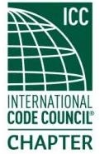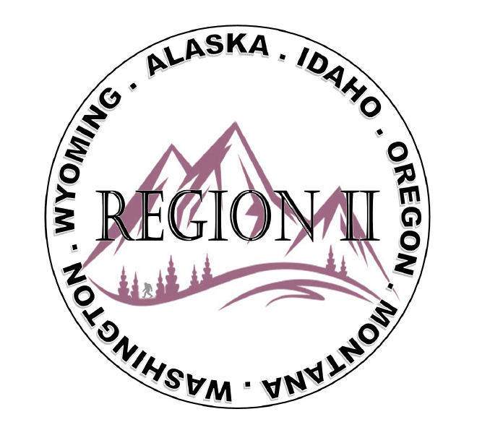
ICC Region II Business Meeting
September 10, 2025
10:00-11:00 A.M PST
- President call meeting to order, Roll Call of R2 Board Members (verify quorum)
- Acceptance of previous meeting minutes, August 13th. Motion required.
- Treasurer’s report, Bret Caulder. Motion required.
- BOD Liaison and ICC Update, and comments – Jim Sayers, other BOD Members.
- ICC Government Relations Liaison – Bryan Imai
- ICC Conference in Cleveland – One Hilton room available for anyone
- Last call for Contact list info – RSVP yourself and +1 to Mixer
- Raffle up on website – $15 each / 3 for $40 - Salmon, Sturgeon, Crab out of Astoria, OR
- Need designated speaker(s) for each State in advance of ABM
- Matrix of R2 Board seats attached for elections
- Watch party capabilities?
- Chemeketa Kickstart Scholarship Fund
- Regional Updates – Alaska, Washington, Wyoming, Oregon, Montana, Idaho
- Comments for the good of the order
- Next meeting in Cleveland, October 19, 2025 3:30pm – 4:30pm EST
- Adjournment. Motion required.
- R2 Nom Com meeting right after the MBM – R2 Board stay online

