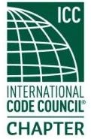
ICC Region II Business Meeting
July 9, 2025
10:00-11:00 A.M PST
- President call meeting to order, Roll Call of R2 Board Members (verify quorum)
- Acceptance of previous meeting minutes, June 11th. Motion required.
- Treasurer’s report, Bret Caulder. Motion required.
- BOD Liaison and ICC Update, and comments – Jim Sayers, other BOD Members.
- ICC Government Relations Liaison – Bryan Imai
- Regional Updates – Montana, Idaho, Alaska, Washington, Wyoming, Oregon
- Comments for the good of the order
- Next meeting, August 13, 2025 10:00a – 11:00am PST
- Adjournment. Motion required.

