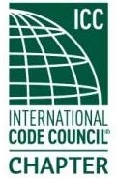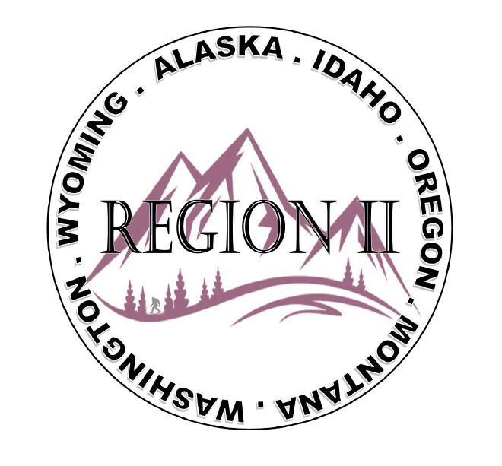
ICC Region 2 Business Meeting
July 10th 2024
10:00-12:00 PST
- President call meeting to order, introduction of guests, roll call.
- Introduction of Region 2 Board, roll call, announcements.
- Acceptance of previous meeting minutes, June 12th 2. 024, Motion required.
- Treasurer’s report, Bret Caulder. Motion required.
- BOD Liaison and ICC Update, and comments – Jim Sayers, other BOD Members.
- Introduction of New ICC Government Relations Liaison – Karen Beebe
- Call to Committee update
8. Interest in Director at large positions.
9. Requests have been made and RII will provide letters of support for various candidates for ICC
Board positions.
10. Regional Updates – Wyoming, Montana, Idaho, Oregon, Washington
11. EOBO chapter ABM Flyer has been added to the R II Site. Are there any other R II Chapters that would like
their event flyer posted on the R II Site?
12. President’s comments, recognition of Region 2 members.
13. Comment for the good of the order.
14. Next meeting August 14th 2024, 10:00-11:00 AM PST.
15. Adjournment. Motion required.
16. Training Opportunity- Today7/10/24 11am-12pm - Noel Curry will present and discuss aspects of
Multi Story, multi family structures, and type A, B, and C units as related to IBC Chapter 11

