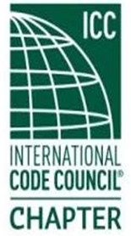 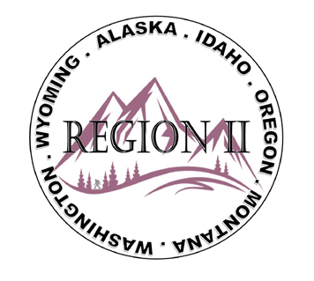

**ICC Region II Minutes**

**February 12, 2025 10am – 11am PST**

1. Roll Call
2. Approval of January minutes – Motion made and approved**.**
3. Treasurer’s Report – Holly gave report. Motion made and approved.
4. **Steven McDaniel** – ICC GR Report – Reminder to check on Memberships & Validations.

**David Spencer** – Reminder of Building Safety Month; Federal Grants; provided current ICC GR update link: https://www.iccsafe.org/wp-content/uploads/2025-February-GR-Update.pdf; Review CP12 A/B/C Standards; March 15th is the Awards nominations deadline; Code of Honor Scholarship deadling is February 21st.

**Jim Sayers** – “Glad to Be Here” reference to the Blue Angels video / John Foley; Region III and EduCode; Code Hearings and Leafdership Week in Orlando; Fall Hearing schedule available February 15th; Recognize Building Safety Month.

**Jack Applegate** – Laison for Indigneous Tribes; Importance of Building Safety Month; BRICK deadline April 18th; FEMA; TownHall Events link; submit your Chapter Reports to myICCsafe.org.

1. Cleveland Mixer at the ICC Conference and Expo has been confirmed for October 20, 2025 at 6p.
2. Militaries Families Committee – President Cache will correspond with Ben Abbey (who volunteered to be on the committee) and coordinate.
3. **ALASKA** – Joe Fisher – Recap of Central Chapter Meeting; Fire Marshals Forum last month; update on AK Housing Finance Corporation’s code adoption; Bart Meinhardt; Fire Marshals Forum: classes on multi-unit Apt bldgs.; Energy Storage Systems**. IDAHO** – Bret Caulder & Cache Olson; Building Code adoption difficulties in Idaho. **MONTANA** – Ben Abbey - MT registration conference in Helena, March 24 – 28; next chapter meeting 2/18. **OREGON** – Chad Wiltrout – Energy Efficient Code 6ms grace perod; new 2 family dwelling provisions amended in 2023 Residential Specialty Code. Katherine Denight – Eastern Oregon Building Code training with variety of code compliance groups- Breck Cook – Confirmed 2025 ABM Driftwood Shores, August 21 – 22. Steven Matiaco – OBOA’s QBM Feb. 28, Maryann County, Block rooms available, registration to be coming. April 15th, Spring Institute. **Jack Applegate** - Coquille Tribe implemented the iCode Family of Solutions; also mentioned ICC ES (Evaluations Service) who provide safe, reliable building products and have recentaly given Specialized Support to Accelerate Los Angeles’ Rebuilding Efforts: <https://icc-es.org/news/icc-es-los-angeles-rebuilding-efforts>; further information on ICC ES Linked In account. **WASHINGTON** - Tim Blevins; WABO March 17 – 20 Lynwood, ABM April 17 – 18, Leavenworth, WA. Quyen Thai – ATC 2025; Spokane on March 5th and Lynwood; <https://wasafecoalition.org/get-training> Sam Steele – Major Jurisdiction Meeting update - LA County issued 10K red-tags in one month; inquiring about purchasing a Rapid Damage Assessment Tool. Logan Garrels – North Central Chapter – ABM March 13-15 in Leavenworth, WA**. WYOMING** – Sean Collier; WYCBO May 14 – 16, website and classes offered update soon; code adoption update.
4. Next meeting, March 12th. Motion and approved to Adjourn.