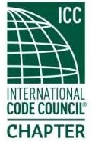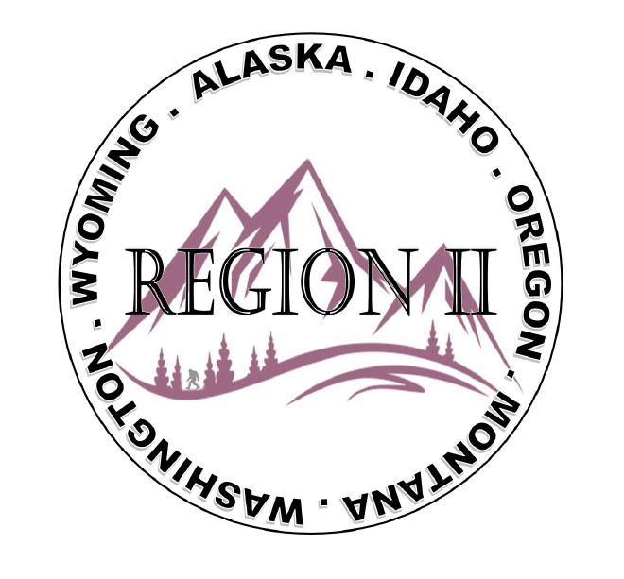
Region II of ICC - Business Meeting
February 12, 2025
10:00 AM -11:00 AM PST
- President call meeting to order – verify quorum
- Introduction of Region II Board, roll call, announcements.
- Acceptance of previous meeting minutes, January 8th. Motion required.
- Treasurer’s report, Motion required.
- BOD Liaison and ICC Update, and comments
- ICC Government Relations Liaison – Bryan Imai
- Update on Cleveland Mixer - Holly
- Call to Committee update – Military Families?
- Regional Updates – Alaska; Idaho; Montana; Oregon; Washington; Wyoming
- Comments for the good of the order
- Next meeting, March 12th
- Adjournment. Motion required.

