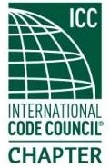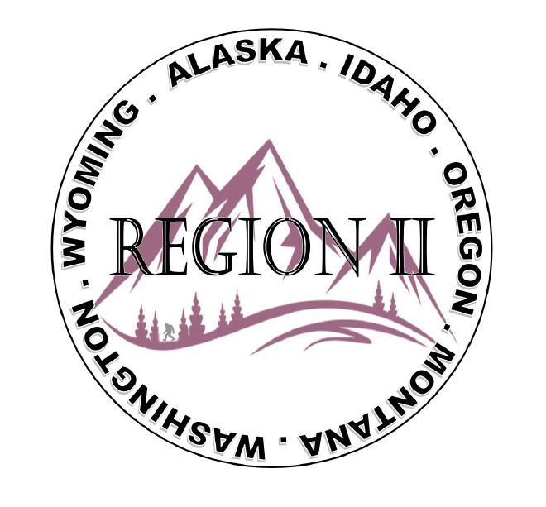
ICC Region 2 Business Meeting
June 12th 2024
10:00-11:00 PST
- President call meeting to order, introduction of guests, roll call.
- Introduction of Region 2 Board, roll call, announcements.
- Acceptance of previous meeting minutes, May 8th 2. 024, Motion required.
- Treasurer’s report, Bret Caulder. Motion required.
- BOD Liaison and ICC Update, and comments – Jim Sayers, other BOD Members.
- Introduction of New ICC Government Relations Liaison – Karen Beebe
- Call to Committee update
8. Will there be scholarships for ABM in October.
9. Fundraising Ideas
10. Regional Updates – Wyoming, Montana, Idaho, Oregon, Washington,
11. PermitTechNation update and call for sponsorship (see attached)- Serena Locke
12. President’s comments, recognition of Region 2 members.
13. Comment for the good of the order.
14. Next meeting July 10th 2024, 10:00-11:00 AM PST.
15. Adjournment. Motion required.

Dear Oregon Permit Technician,
In 2014, during the ICC Annual Conference in Fort Lauderdale, FL, Women in Code Enforcement and Development (WICED) collaborated with Habitat for Humanity for their inaugural "Day of Service," with PermitTechNation (PTN) joining WICED at the 2015 ICC AC in Long Beach, CA. This year marks the 10th anniversary of this impactful volunteer program. In partnership with the International Code Council and Habitat for Humanity of Greater Los Angeles, this year’s “Day of Service” will support the Century Villages at Cabrillo on Saturday, October 19, 2024.
We are reaching out to individuals and organizations in our communities, who share in our passion for public service and giving back to the community, for their support and sponsorship. Your assistance will provide the means to ally with Habitat for Humanity in rejuvenating this community. As we endeavor to accommodate more than 100 volunteers, the allocated funds will be utilized to guarantee that our teams operate in a safe and secure environment while engaging in giving back to the community.
It is through the generosity of you, members of the building community, that we can make a difference in the lives of those we serve. The funding needs for these programs differ based on their respective locations. To secure a suitable site for this year's projects and facilitate the planned beautification efforts, we rely on your support to help us achieve our $10,000 fundraising goal. Your donation will directly impact the lives of the individuals and families in this community, a significant portion of whom, up to 40%, are United States Veterans.
While on-site, we discuss work site safety information and OSHA regulations, codes compliance for building, electrical, mechanical, and plumbing codes as they pertain to the scope of work of the build. Safety and compliance are paramount. In the past, we have performed construction tasks such as wall framing, insulation installation, drywall hanging, painting, and landscaping. At last year's “Day of Service”, we raised the largest single wall in St. Louis Habitat for Humanity history at 96 feet long.
To make a monetary donation, please complete the donation form. Once completed, you will receive a receipt for your tax-deductible donation. Your support is invaluable in helping us achieve our mission to make a meaningful impact on the communities we visit.
Sincerely,
Eirene Knott, WICED Co-Founder and Christina Jackson, PTN Board Member
Day of Service Co-Chairs

ABOUT OUR ICC CHAPTERS
PTN was founded in 2013 by a few enthusiastic individuals to advocate for and provide education and mentorship for Permit Technicians and building department officials.
WICED was founded in 2007 for the benefit of providing mentoring, advocacy, and education to the women in the arena of code enforcement and development.
Both organizations are International Code Council (ICC) Professional Chapters and responsible for ensuring that the built environment meets the minimum required safeguards for people at home, school and in the workplace.

Sponsorship Tiers:
Blueprint - Your generous donation of up to $499 will be recognized with your company or chapter name featured on the PermitTechNation and Women in Code Enforcement & Development websites and social media sites.
Foundation – Your generous donation of $500-$999 will be recognized with your company or chapter logo featured on the PermitTechNation and Women in Code Enforcement & Development websites and social media sites. Please email your logo to info@permittechnation.org
High Rise – Your generous donation of $1,000 or more will be recognized with your company or chapter logo on the Day of Service T-Shirts, and featured on the PermitTechNation and Women in Code Enforcement & Development websites and social media sites. Please email your logo to info@permittechnation.org

