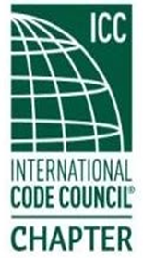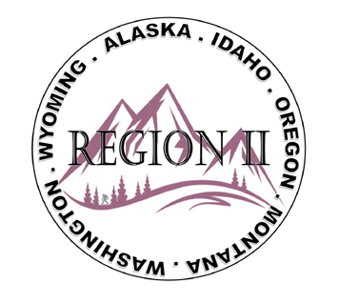

ICC Region II Minutes
July 8, 2026 10am – 11am PST
- Call to order at 10:02 am, confirmed quorum.
- Roll call of board and introductions.
- Motion made and approved of submitted minutes from November 2025
- Treasures report submitted and approved – June Balance $20,449.80
- Ron Clements – Excused Absence
- Bryan Imai – (1) Chapter Presidents look for link for registration to ABM, if did not receive contact Bryan. (2) Expanded A3 Refrigerants, watch for status updates.
- Director Jessica Fust - Absent
- Director Andy Higgins – (1) Looking for letters of support for election (2) Application for membership governing councils closes July 15.
- Director Jim Sayers – Absent
- Director Jack Applegate – (1) Reach out to legislature about Procodes Act support (2) CDP Access website, ICC has improved it to make it more user friendly (3) Data Center guideline updates (4) Read Building Safety Journal.
- Director Ben Breadmore – (1) Candidate website nominations to be operational August (2) ICC now has 70,000 members (3) ICC bylaws update.
- President Mike Boso – (1) ICC Board meeting on 7-11-2026 (2) Hope everyone can make it to the ABM
- Regional updates
WASHTINGTON:
WABO summer meeting July 16-17

MONTANA:
Adopted code waiting on State, July 16th is the start of the public comments
IDAHO:
No update on code adoption

WYOMING:
Wyoming 50th anniversary coming up in Cody Wyoming. Had to remove fishing due to low water in the area. WCBO website is up, raffle tickets available, auction for a ranch vacation, 1 of 1 belt buckle.
OREGON:
- OPTA annual conference, 2 classes coming up – Sept complete permit tech virtual training (2) 9-12 committee meeting at ABM for PTN and others
Alaska:
No updates
- Next meeting, August 12, 2026. Motion and approved to Adjourn.
- Other Region 2 information
  - Region 2 raffle tickets available on website $15 or 3 for $40. Will be used as scholarship for free registration and $1000 for expenses to ABM. Online application will be available next week.
  - Banking finalized for new bank accounts.
  - Donations were $500 Ron Burton and $1500 WICED and $500 PTN day of Service
  - Will have Pins and Shirts (polo style) for ABM
  - Spotlight quarterly newsletter on 2 rank and file members
  - WICED R2 training July 15 – Fire and Inspection and code Enforcement
  - R2 training Dec 9th – Types of Construction
  - Southern Oregon Chapter of ICC (SOCICC) Aug 20-21 Seafood Boil
  - August 4-7 Wyoming 50th annual business meeting
ATTENDEES:
Region 2 officers
Present - Cashe Olson (Immediate Past President)
Present - Ted Zuk (Region 2 President)
Present - Bret Caulder (Vice-President)
Present - Breck Cook (Treasure)
Present - Bart Meinhardt (Secretary)
Present - Tim Blevins (Director 1)
Present - Amy Williams (Director 2)
Present - Holly Carothers (Director 3)
Present - Ben Abbey (Director 4)
Guest(s):
Mike Boso, Benjamin Breadmore, Sam Zahorka, Katherine Denight, Jack Applegate, Melany Klemmer, Kelly Thompson, Stephanie Day, Serena Locke, Al Rossi, Elizabeth Torske, Van Wilfinger, Chase Hardee, Sean Callier, Sten Matiaco, Andy Higgins, Derrick Moon, Jason Gray, Bryan Imai, Angela Haupt, Bobbi Kaufman, Craig Etherton

