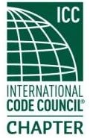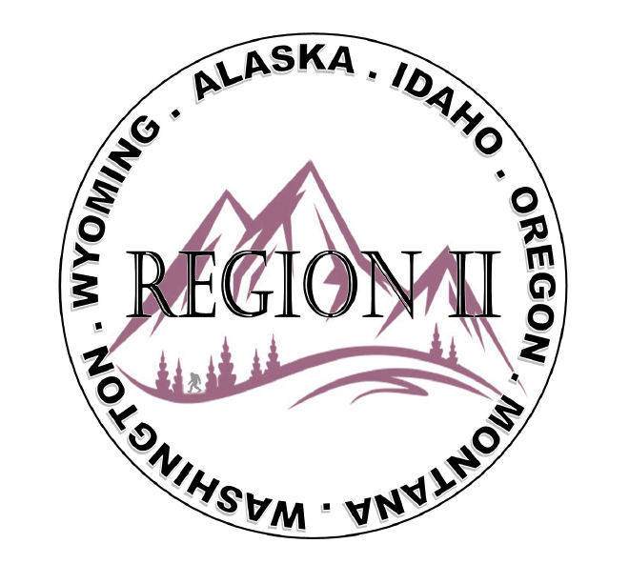
ICC Region 2 Business Meeting MINUTES July 10th 2024 10:00-11:00 PST
- President Olson called meeting to order at 10:04 PST. Roll call: President-Cache Olson, Vice President-Ted Zuk, Treasurer-Bret Caulder, Secretary - Breck Cook, Past President- Andie Lorenz, Directors-Tim Blevins; Chad Wiltrout; Joe Fisher; Bart Meinhardt- Not Present. Total of 27 participants.
- Introduction of Region 2 Board, announcements. President Olson provided general updates.
- Acceptance of previous meeting minutes, June 12th, 2. 024 Motion required. M- Mike Boso, S-Andie Lorenz, Motion approved.
- Treasurer’s report -Bret Caulder. Motion required. M- Jack Applegate, S- Tim Blevins, Motion approved
- BOD Liaison and ICC Update, and comments – ICC board member Mike Boso was on the call and talked about the Long Beach ABM being the biggest and best ever. Mike suggested bringing a friend to the ABM and how important Networking at the conference is. Mike also reminded everyone about voter Validation. ICC Board member Jim Sayers was on the call and provided ICC updates and talked about Technical Training program changes that will be good for members. More to follow. Thank you to RII for support as he runs for ICC Board Secretary Treasurer. ICC director Steven McDaniel provided updates and Talked about how great the conference in Long Beach will be with lots going on. Steve suggested attendees download the ABM App. Steve also requested support for the upcoming Secretary treasurer elections. Jack Applegate provided updates on the Pronto Testing and new on paper testing opportunity. Jack also recommended attendance at the ICC annual conference in October and recommended participating in the building tours. Leslie Garland attended for Karen Beebe and talked about new features of digital code premium that will help users in day to day work. Application still available for Grant money. Karen will attend regional meeting on Sunday in Long Beach.
- Committee Reports. Bylaws-no report, Budget-previously reported, Code Development- No report Awards/Nominations-no report, Military Family-no report. Membership-no report, Education-no report.
- Old Business- Discussion regarding Region II Chapter present fundraising – training - Raffle tickets for guided fishing trip in Montana? Cost for Travel will not be covered. Raffle tickets to be sold at ABM in Long Beach.
- Andie let everyone know that Position 2/3 Director at large positions will be open and to send a letter to the board if interested. Letters of support for ICC candidates to go out after WPLBO conference.
- Andie Made a motion to sponsor a hole at the Ron Burton Golf Tournament in October for $500 Tim Blevins Second – Motion carries.
- Jack made a motion to donate towards a fly Rod retirement gift for Dominic Sims. Ted amended the Motion to purchase the Fly Rod and Bret made the second. Motion Carries. Ben Abbey will put the package together.
- Melany Klemmer provided OPTA /PTN Update and let all know about their conference in Salem November 6,7,8.
- Regional Updates – Wyoming, Montana, Idaho, Oregon, Washington, and Alaska. Regional Educational opportunities have been added to R II website.
- Adele Schaffeld provided the EOBO update and confirmed that their ABM would be in Pendleton Oregon on October 11.
- Ted in regards to the R II Raffle mentioned that there should be secondary raffle prizes. Also looking for sponsors for the R II social in Long Beach.
- Ted made a Motion for RII to send President Cache Olson to the AMB Tim Blevins second the motion- -motion carries
- Comment for the good of the order. - President Olson commented on mentorship and the importance of getting young people involved in building codes.
- Next meeting August 14th, 2024 at 10:00 AM PST.
- Adjournment. (11:04 AM PST) Motion required. M-Jack Applegate, S-Jim Sayers, Motion approved.

