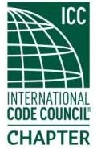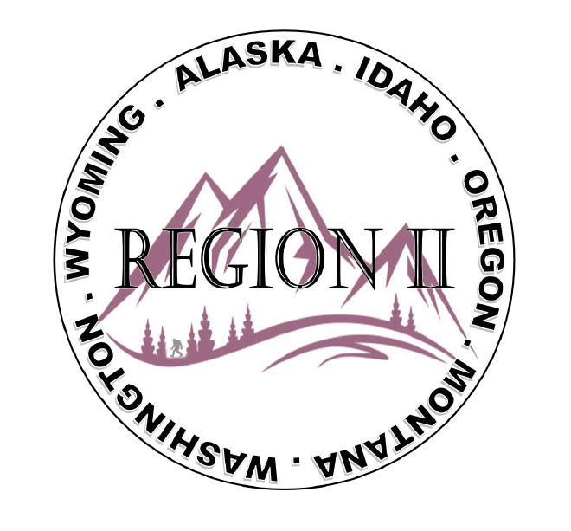
ICC Region 2 Business Meeting
January 10th 2024
10:00-12:00 PST
- President call meeting to order, introduction of guests, roll call.
- Introduction of Region 2 Board, announcements.
- Acceptance of previous meeting minutes, December 13th 2. 023, Motion required.
- Treasurer’s report, Bret Caulder. Motion required.
- BOD Liaison and ICC Update, and comments – Jim Sayers, other BOD Members.
- ICC Government Relations Liaison – Kraig Stevenson.
- Committee Reports.
- Old Business- Fundraising Ideas? Raffle prizes - T shirts- Classes- Instructor?
New Business- Call to Committee. Consolidating all committee into 5 groups-

- Bylaws and Policy
- Budget
- Awards and Nominations
- Education , Code Development
- Military Families , Outreach and Membership

- Membership Dues, Raise Dues? current membership form,
- Holly is working to consolidate/update chapter contacts. Please provide updated Chapters of Region II contact information.
12. Regional Updates – Wyoming, Montana, Idaho, Oregon, Washington, Alaska.
13. President’s comments, recognition of Region 2 members.
14. Comment for the good of the order.
15. Next meeting February 14th 2024, 10:00-12:00 AM PST.
16. Adjournment. Motion required.

