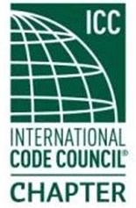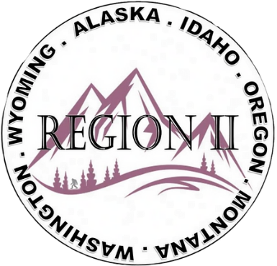

ICC Region II Business Meeting
August 12, 2026
10:00-11:00 A.M. PST
- President call meeting to order, Roll Call of R2 Board Members (verify quorum)
- Approval of previous meeting minutes, July 8th. Motion required.
- Treasurer’s report, Acceptance of Treasurer’s Report. Motion required.
- BOD Liaison Ron Clements with ICC Update, and comments
- Other ICC BOD members acknowledged and provide updates
- ICC Government Relations Liaison – Bryan Imai
- Nashville ABM room block – Government Rate rooms available
- Region II Annual Raffle – Tickets available for purchase on the website
- Regional Updates – Washington, Wyoming, Oregon, Montana, Idaho, Alaska
- Comments for the good of the order
- Discussion items for next meeting – let us know what you want to discuss
- Next meeting September 9, 2026, 10:00am PST
- Adjournment. Motion required.

