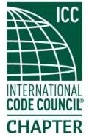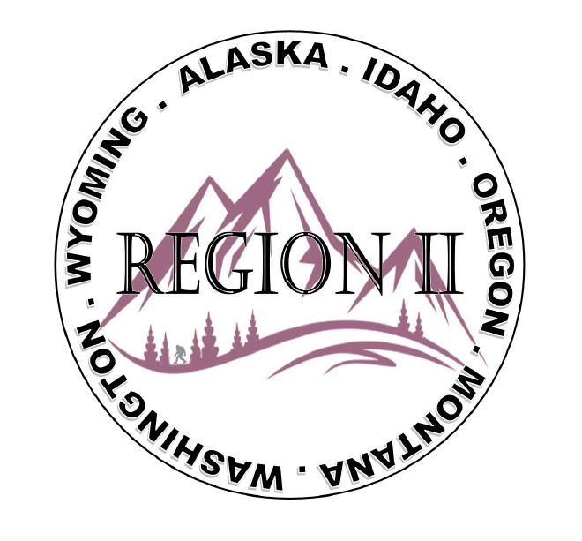
ICC Region 2 Business Meeting MINUTES May 8th 2024 10:00-11:00 PST
- President Olson called meeting to order at 10:02 PST. Roll call: President-Cache Olson, Vice President-Ted Zuk not present, Treasurer-Bret Caulder, Secretary - Breck Cook, Past President- Andie Lorenz not present, Directors-Tim Blevins; Chad Wiltrout; Joe Fisher; Bart Meinhardt -Total of 27 participants
- Introduction of Region 2 Board, announcements. President Olson provided general updates.
- Acceptance of previous meeting minutes, April 10th, 2. 024 Motion required. M- Joe Fisher, S-Bart Meinhardt, Motion approved.
- Treasurer’s report -Bret Caulder. Motion required. M- Bart Meinhardt, S- Tim Blevins, Motion approved
- BOD Liaison and ICC Update, and comments – ICC Board member Jim Sayers was on the call and provided ICC updates and an update on the search to replace ICC CEO Dominic Simms. Jim also spoke about the ICC 30th anniversary, how that will affect the ABM in Long Beach, and the ICC’s desire to have 3000 in attendance. OBOA 50th Anniversary mentioned. Thank you to RII for support as he runs for ICC Board Secretary Treasurer. ICC director Steven McDaniel provided updates and requested support for the upcoming Secretary treasurer elections.

- ICC Government Relations Liaison – Kraig Stevenson spoke about the importance of Building safety month, and how critical it is to recruit young people into the industry. Mentioned promoting the ICC leadership academy to the same young people. Kraig also discussed the benefits to adding the QR codes in the margin of the new code books.
- Committee Reports. Bylaws-no report, Budget-previously reported, Code Dev- Ted Zuk discussed possibly collaborating with Northern Calif. and Washington Chapters. Awards/Nominations-no report, Military Family-Previously updated by Jack, Breck will send an interest email to membership regarding potential scholarship candidates. Membership-no report, Education-no report.
- Old Business- Discussion regarding Region II Chapter present fundraising – training - Raffle tickets for guided fishing trip in Montana? Cost for Travel? Travel will not be covered. Raffle tickets to be sold at ABM in Long Beach.

- Regional Updates – Wyoming, Montana, Idaho, Oregon, Washington, Alaska. Regional Educational opportunities have been added to R II website.

- Comment for the good of the order. None.
- Next meeting June 12th, 2024 at 10:00 AM PST.
- Adjournment. (10:56 AM PST) Motion required. M-Steve Matiaco, S-Bart Meinhardt, Motion approved.

