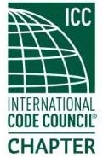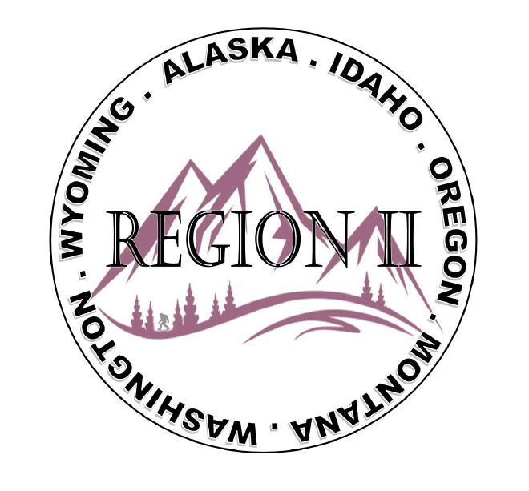
ICC Region 2 Business Meeting MINUTES February 14th 2024 10:00-11:00 PST
- Vice President Zuk called meeting to order at 10:05 PST. Roll call: President-Cache Olson-not present, Vice President-Ted Zuk, Treasurer-Bret Caulder, Secretary - Breck Cook Past President- Andie Lorenz Directors-Tim Blevins; Chad Wiltrout; Joe Fisher; Bart Meinhardt -Total of 24 participants
- Introduction of Region 2 Board, announcements. Vice President Zuk provided general updates.
- Acceptance of previous meeting minutes, January 10th, 2. 023 Motion required. M- Bart Meinhardt, S-Serena Locke, Motion approved.
- Treasurer’s report -Bret Caulder. Motion required. M- Serena Locke , S- Bart Meinhadt, Motion approved.
- Additional Agenda items -Discussion regarding using funds recently received for military Family sponsorship to Chapter leadership academy and ICC ABM. Who will complete chapter reports for Chapter rewards.
- Acceptance of Agenda as Modified- M- Bret Caulder S- Serena Locke Motion Approved
- BOD Liaison and ICC Update, and comments – ICC Board member Steve McDaniel was on the call and provided ICC updates as was David Spencer who provided various updates from ICC and a reminder about updating Government Voting members. Jim Sayers was also on the call and reminded us about Upcoming Building safety month
- ICC Government Relations Liaison – Kraig Stevenson spoke about the importance of submitting Building safety month proclamations. Kraig also spoke of the importance of completing the ICC annual report and the points that can be obtained for the report throughout various building safety month activities.
- Committee Reports. Bylaws-no report, Budget-previously reported, Code Dev- Ted Zuk discussed possibly collaborating with Northern Calif. and Washington Chapters. Awards/Nominations-no report, Military Family-Previously updated by Jack, Membership-no report, Education-no report.
- Old Business- Discussion regarding Region II Chapter present fundraising – training - Raffle tickets for guided fishing trip in Montana? Cost for Travel?
Holly still collecting/updating chapter contact info. Andie will work on getting Region 2 files on thumb drives and mailing them to the board. Motion for Ben Abbey to send flyer that could be posted to generate interest M-Bret Caulder S -Jim Sayers
During discussion there was a concern as to whether a permit was required to sell raffle
Tickets subject was tabled for next meeting
$1500 Donation to WLICE to be split up amongst region 2 chapters Tabled for next meeting

- Regional Updates – Wyoming, Montana, Idaho, Oregon, Washington, Alaska. Regional Educational opportunities have been added to R II website.

- Comment for the good of the order. None.
- Next meeting March 13th, 2024 at 10:00 AM PST.
- Adjournment. (11:20 AM PST) Motion required. M-Steve Matiaco, S-Joe Fisher, Motion approved.

