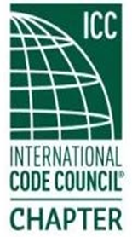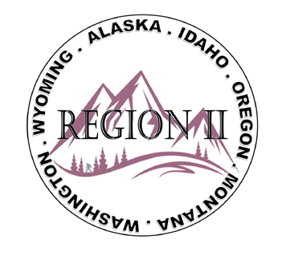

ICC Region II Minutes
June 10, 2026 10am – 11am PST
- Call to order at 10:04 a.m, confirmed quorum.
- Roll call of board and introductions.
- Motion made and approved to accept minutes for April and May.
- Treasures report given and approved – Balance $20,166.10
- President
- Director Ron Clements – Emory Rogers Scholarship open until 12/15; A17 Standard 2026 edition in 2027 code; Middle Housing publication; ICC reached 70K+ member milestone;.
- Director Breadmore – Bylaw changes at ABM; updating 30yr ICC brand and governance;
- Director Jack Applegate – Building Safety Journal re: gate code;
- Bryan Imai – ICC Government Relations – Multi Family Edition is now out; High Density Multi ; ICC Survey is still open: Benchmarks for permit fees and plan review timelines ; reminder to use your Chapter Benefits for Education.
- Region II Webinar – 2024 IBC Types of Construction and Application – December 9, 2026 in lieu of monthly meeting.
- Director Andy Higgins, President Mike Boso, Director Jessica Fust – Absent
- Motion made and approved to sponsor the Ron Burton Golf Tee #2 and Hole #2 - $500
- Motion made and approved to sponsor the Chemeketa College BITS Fund - $1,500
- Motion made and approved to sponsor the PTN / WICED Day of Service - $1,000
- Regional updates:
WYOMING: Jim Brown - WYBO Scholarships for post-high school students entering
Code Specialist jobs. 50th Anniversary to Wyoming Building Officials
August 5 – 8, 2026; raffle tickets on sale on website www.wyomingcbo.com
OREGON: Dan Carlson spoke on: Student Chapter Meeting last month, Director Applegate did the swearing in of new officers, Heaven Dougherty is moving into past-president after a 2yr term. Kylee VanOrman Sec/Treasurer spoke on ABM for 2027 is Baker, Oregon; Amy Williams spoke on OBOA registration for education is now on the website; SOCICC is having a training course and registration for SOCICC ABM in Florence, OR is August 20-21.
MONTANA: Building Codes Council met with the State newly adopted codes; energy
Code; Rural event venue. New board members in Montana Big Sky Chapter.

IDAHO: Rule to Statutes in meeting, no updates confirmed. City of Meridian utilized ICC tools to combine with Public Works Dept to educate younger

ALASKA: Nothing to report.

WASHINGTON: Past President Ray Cocherham spoke on WABO, Todd Blevins is President; Summer meeting in Richland WA Aug. 16 – 17 is virtual; Canvas crash ordeal and successfully WABO; DIW contact has started; State Building Code Council; Stephanie Day spoke on WSAPT update: Fall Conference and ABM Sept. 21 – 22; updated bylaws: 2 new board members to be added.

- Jim Brown mentioned Building Safety Leadership applicant, Sean Collier.
- Nashville ABM raffle prize at R2 Mixer will be the Orvis Fly Fishing package and gift cards - $15 per ticket or 3 tickets for $40.
- Region 2 swag; Pens and T-shirts to be coming out
- Director Applegate – Encouraged anyone to reach out to ICC board and share any scholarship concepts.
- Next meeting, July 8, 2026. Motion and approved to Adjourn.
ATTENDEES:
Region II Officers:
Absent excused - Cache Olson (Immediate Past President)
Present - Ted Zuk (Region 2 President)
Present - Bret Caulder (Vice-President)
Present - Breck Cook (Treasurer)
Absent excused - Bart Meinhardt (Secretary)
Present - Tim Blevins (Director 1)
Present - Amy Williams (Director 2)
Present - Holly Carothers (Director 3)
Present - Ben Abbey (Director 4)
Members:
Jim Brown, Andie Lorenz, Bobbie Kaufman, Ben Abbey, Jack Applegate, Ted Zuk, Steve Matiaco, Amy Williams, Russ at NRF, Andie Lorenz, Benjamin Breadmore, Bret Caulder, Bryan Imai, C. Nunley, Dan Carlson, Derrick Moon, Devon Linebaugh, Elizabeth Torske (CNGC), Hoyt Jeter, Kevin Harmon, Kylee VanOrman, Quyen Thai, Ray Cockerham, Serena Locke, Stephanie Day, Tela Gardner, Tim Blevins, Ron Clements.

