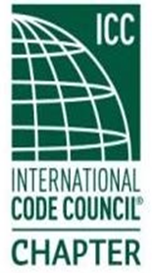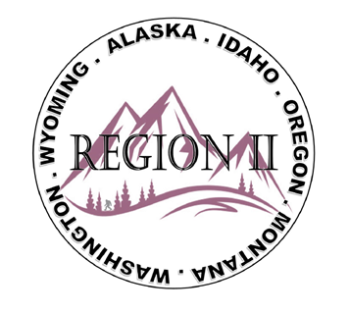

ICC Region II Minutes
February 11, 2026 10am – 11am PST
- Call to order at 10:06 am, confirmed quorum.
- Roll call of board and introductions.
- Motion made and approved of submitted minutes from January 2026
- Treasures report – January balance $20,412.85
- ICC Nation Directors Reports
Director Ron Clements – Present
Call for Code Development Committee members due by April 1, 2026
https://www.iccsafe.org/building-safety-journal/bsj-technical/call-for-committee-2027-2029-cycle-committees/
Building Safety website active
2026 Building Safety Month - ICC
Bryan Imai – IECC – comments on scop and intend due February 15, Code of Honor Scholarship Information due February 18; ICC Awards: https://url.us.m.mimecastprotect.com/s/NYTjCJ6KykiqrwZkfvt1HyTCmo/
Building Safety Month: https://www.iccsafe.org/advocacy/building-safety-month/building-safety-month/
Director Jack Applegate – Absent (Happy Birthday, Jessica!)
Director Andy Higgins – Present
Congratulations to Sam Steele, interim Director at SDCI

Instructor resources
Technical Training Program - ICC
https://www.iccsafe.org/professional-development/safety2/technical-training-program/#instructors

- Regional updates
WASHTINGTON:
Legislation re: 3rd party eliminating of juristiction
Legislation for Energy Code
WSAPT – Spring Conference April 20-21, 2026
WABO.org – Education dates on March 16 – 20
https://wsapt.org/event-6442054
https://www.wabo.org/2026-aei-summary-page

MONTANA:
March 30 – April 2 – ABM State Chapter and Education in Missoula.
https://www.eventsquid.com/event.cfm?id=29615
Bylaw updates in March 2026
State Legislature talk of spearheading Building Codes
IDAHO:
2024 codes moving to House business
WYOMING:
Nick Hudson – no report for Wyoming

OREGON:
EOBOA: Conference May 14 – 15 Dalles, OR
Chemeketa Chapter of ICC Report:
We have 23 students in the middle of winter term of their first year of their AAS degree. We are recruiting instructors for the Building Inspection Technology program. The intention is to build depth into our current roster of amazing instructors to assist with classes as the need arises. This recruitment closes on February 19. Teaching the next generation is incredibly rewarding. If you or someone you know is interested in being considered, an application can be completed at the link: https://url.us.m.mimecastprotect.com/s/qA5SCM8gwjuqGAERIwf6I8A1Lj?domain=schooljobs.com

Alaska:

- Region 2 Training Opportunities
March 11 AI Webinar (Region 2)
April 17-18 ICC Chapter Leadership Academy, Hartford Connecticut

- Next meeting topics
  - AI Class following March meetings – Last minute sign up’s welcome! Donations appreciated!

- Next meeting, March 11, 2026. Motion and approved to Adjourn.
ATTENDEES:
Region II officers
Present - Cache Olson (Immediate Past President)
Present - Ted Zuk (Region 2 President)
Present - Bret Caulder (Vice-President)
Present - Breck Cook (Treasurer)
Present - Bart Meinhardt (Secretary)
Absent - Tim Blevins (Director 1)
Absent - Amy Williams (Director 2)
Present - Holly Carothers (Director 3)
Present - Ben Abbey (Director 4)
Guests (25):
Adele Schaffeld, Director Higgins (ICC), Breck Cook, Andie Lorenz, President David Jackson (NACO), C. Nunley, Cache Olson, Kelly Thompson, Kylee VanOrman, Bryan Imai (ICC Gov’t Relations), Tela Gardner, Hoyt Jeter, Director Clements (ICC R2 laison), Dan Carlson, Steven Matiaco, Devon Linebaugh, John Rodriguez, Derrick Moon, Brian Dorland, Craig Etherton, Nicole Thomson, Al Rossi, Marc Bangma, Nick Hudson.

