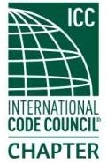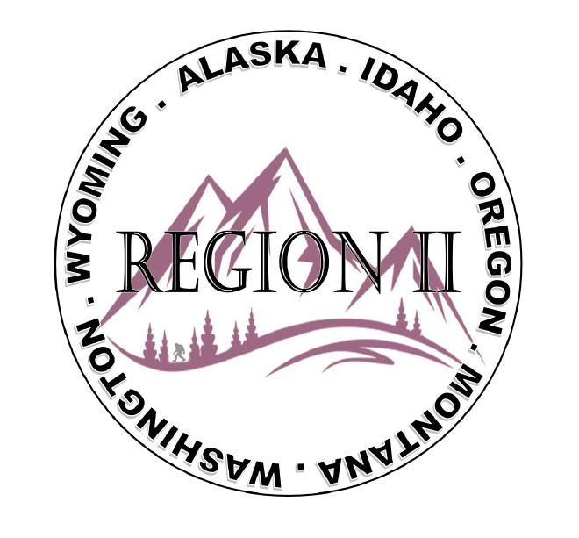
ICC Region 2 Business Meeting MINUTES June 12th 2024 10:00-11:00 PST
- President Olson called meeting to order at 10:04 PST. Roll call: President-Cache Olson, Vice President-Ted Zuk, Treasurer-Bret Caulder, Secretary - Breck Cook, Past President- Andie Lorenz, Directors-Tim Blevins; Chad Wiltrout - not present; Joe Fisher; Bart Meinhardt -Total of 27 participants
- Introduction of Region 2 Board, announcements. President Olson provided general updates.
- Acceptance of previous meeting minutes, May 8th, 2. 024 Motion required. M- Jim Sayers, S-Bart Meinhardt, Motion approved.
- Treasurer’s report -Bret Caulder. Motion required. M- Joe Fisher, S- Tim Blevins, Motion approved
- BOD Liaison and ICC Update, and comments – ICC Board member Jim Sayers was on the call and provided ICC updates and an update on the Energy Code Committee. Thank you to RII for support as he runs for ICC Board Secretary Treasurer. ICC director Steven McDaniel provided updates and reminder of deadline for applications to ICC leadership experience. Steve also requested support for the upcoming Secretary treasurer elections. Jack Applegate provided updates on ICC Native American Chapter NACO and suggested becoming a member to support. Jack also recommended attendance at the ICC annual conference in October.
- Committee Reports. Bylaws-no report, Budget-previously reported, Code Dev- Ted Zuk discussed possibly collaborating with Northern Calif. and Washington Chapters. Awards/Nominations-no report, Military Family-Previously updated by Jack. Membership-no report, Education-no report.
- Old Business- Discussion regarding Region II Chapter present fundraising – training - Raffle tickets for guided fishing trip in Montana? Cost for Travel will not be covered. Raffle tickets to be sold at ABM in Long Beach.
- Regional Updates – Wyoming, Montana, Idaho, Oregon, Washington, Alaska. Regional Educational opportunities have been added to R II website.
- Comment for the good of the order. - President Olson commented on mentorship and the importance of getting young people involved in building codes.
- Next meeting July 10th, 2024 at 10:00 AM PST.
- Adjournment. (11:30 AM PST) Motion required. M-Steve Matiaco, S-Bart Meinhardt, Motion approved.

