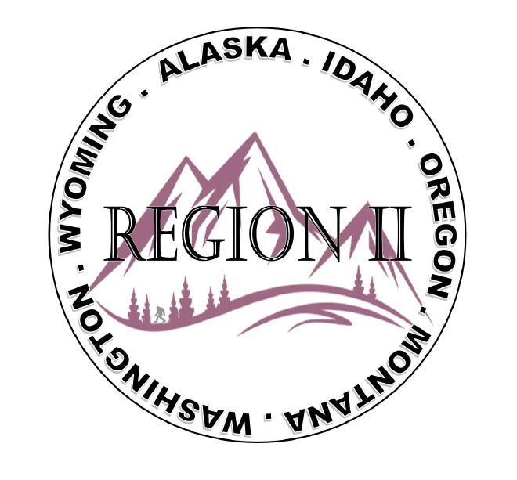
ICC Region 2 Business Meeting
February 14th 2024
10:00-12:00 PST
- President call meeting to order, introduction of guests, roll call.
- Introduction of Region 2 Board, announcements.
- Acceptance of previous meeting minutes, January 10th 2. 024, Motion required.
- Treasurer’s report, Bret Caulder. Motion required.
- BOD Liaison and ICC Update, and comments – Jim Sayers, other BOD Members.
- ICC Government Relations Liaison – Kraig Stevenson.
- Call to Committee update
- Old Business- Fundraising Ideas? Raffle prizes - T shirts- Classes- Instructor?
New Business- How to use the Benefit training proceeds for military families?
9. Will R II send a board member to ICC leadership academy in Orlando?
10. Should R II Sponsor the WLCE event taking place in April in Austin?
11. Holly is still working to consolidate/update chapter contacts.
12. Regional Updates – Wyoming, Montana, Idaho, Oregon, Washington, Alaska.
13. President’s comments, recognition of Region 2 members.
14. Comment for the good of the order.
15. Next meeting March 13th 2024, 10:00-12:00 AM PST.
16. Adjournment. Motion required.

