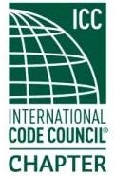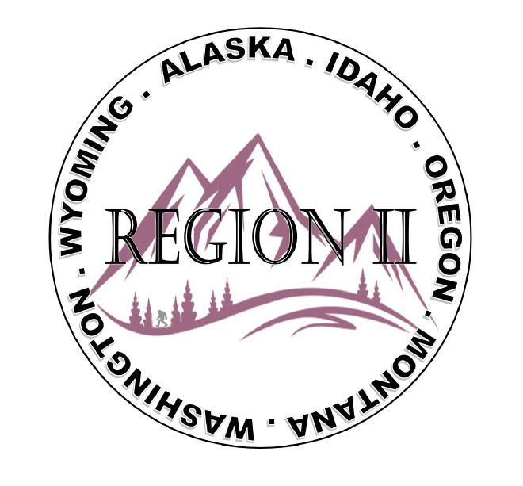
ICC Region 2 Business Meeting MINUTES March 13th 2024 10:00-11:00 PST
- President Olson called meeting to order at 10:02 PST. Roll call: President-Cache Olson, Vice President-Ted Zuk, Treasurer-Bret Caulder, Secretary - Breck Cook Past President- Andie Lorenz Directors-Tim Blevins; Chad Wiltrout; Joe Fisher; Bart Meinhardt -Total of 25 participants
- Introduction of Region 2 Board, announcements. President Olson provided general updates.
- Acceptance of previous meeting minutes, February 14th, 2. 023 Motion required. M- Andie Lorenz, S-Chad Wiltrout, Motion approved.
- Treasurer’s report -Bret Caulder. Motion required. M- Holly Carothers , S- Andie Lorenz, Motion approved
- BOD Liaison and ICC Update, and comments – ICC Board member Mike Boso was on the call and provided ICC updates as was Steve McDaniel who provided various updates from ICC, a reminder about nominations for ICC awards and let us know he was looking for support as he would be running for ICC board secretary treasurer in Long Beach.
- ICC Government Relations Liaison – Kraig Stevenson spoke about the importance of submitting annual report and Building safety month proclamations. Kraig also spoke of the importance designating voters prior to March 20 deadline. Will send info once available for ICC Board Shadow program and any deadline.
- Committee Reports. Bylaws-no report, Budget-previously reported, Code Dev- Ted Zuk discussed possibly collaborating with Northern Calif. and Washington Chapters. Awards/Nominations-no report, Military Family-Previously updated by Jack, Membership-no report, Education-no report.
- Old Business- Discussion regarding Region II Chapter present fundraising – training - Raffle tickets for guided fishing trip in Montana? Cost for Travel?
11. Motion for Ben Abbey to send flyer that could be posted to generate interest M-Bret Caulder S -Jim Sayers
During discussion there was a concern as to whether a permit was required to sell raffle
Tickets subject was tabled for next meeting
$500 Donation to WLICE

- Regional Updates – Wyoming, Montana, Idaho, Oregon, Washington, Alaska. Regional Educational opportunities have been added to R II website.

- Comment for the good of the order. None.
- Next meeting April 10th, 2024 at 10:00 AM PST.
- Adjournment. (11:07 AM PST) Motion required. M-Andie Lorenz, S-Ted Zuc, Motion approved.

