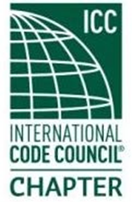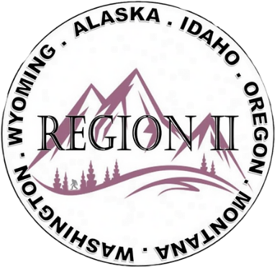
ICC Region II Business Meeting
March 11, 2026
10:00-10:45 A.M. PST
- President call meeting to order, Roll Call of R2 Board Members (verify quorum)
- Approval of previous meeting minutes, February 11. Motion required.
- Treasurer’s report, Breck Cook. Acceptance of Treasurer’s Report. Motion required.
- BOD Liaison Ron Clements with ICC Update, and comments
- Other ICC BOD members acknowledged and provide updates
- ICC Government Relations Liaison – Bryan Imai
- Business / Action Items:
- President Zuk - Report on ICC Annual report and awards
- 2026 Chapter Leadership Academy April 17–18, 2026 | Hartford, CT ** FREE registration, air and hotel **
- Region II Chapters:
Chapter of the Year; Spotlight on Chapter; Chapter Merit Awards
- Revamping of website
- New ICC Code Enforcement Program – Three certifications
Upcoming Trainings:
- Upcoming Trainings:
AI Webinar Class with Ed Cilurso immediately following today’s meeting
SAVE THE DATE! April 8th at 10:45 a.m. PST - Shirley Ellis sharing:
Who? How? What? When? Class on Code Change Process
- Regional Updates – Washington, Wyoming, Oregon, Montana, Idaho, Alaska
- Comments for the good of the order
- Next meeting April 8, 2026, 10:00am – abbreviated meeting ending approximately at 10:45am PST
- Shirley Ellis – Code Change Process Class starts at 10:45 a.m. after our meeting
- Adjournment, motion required.

