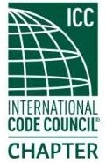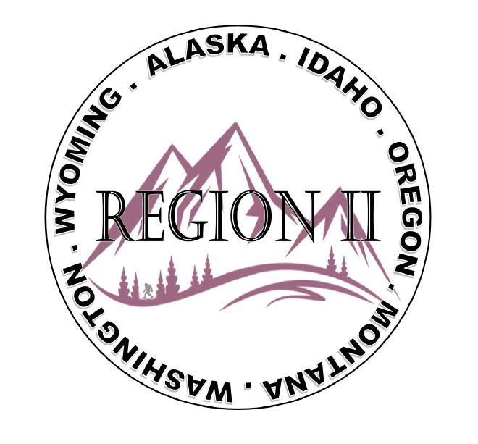
ICC Region 2 Business Meeting
May 8th 2024
10:00-11:00 PST
- President call meeting to order, introduction of guests, roll call.
- Introduction of Region 2 Board, roll call, announcements.
- Acceptance of previous meeting minutes, April 10th 2. 024, Motion required.
- Treasurer’s report, Bret Caulder. Motion required.
- BOD Liaison and ICC Update, and comments – Jim Sayers, other BOD Members.
- ICC Government Relations Liaison – Kraig Stevenson.
- Call to Committee update

8. Will there be scholarships for ABM in October.
9. Fundraising Ideas
10. Regional Updates – Wyoming, Montana, Idaho, Oregon, Washington,
11. President’s comments, recognition of Region 2 members.
12. Comment for the good of the order.
13. Next meeting June 12th 2024, 10:00-11:00 AM PST.
14. Adjournment. Motion required.

