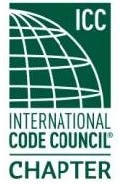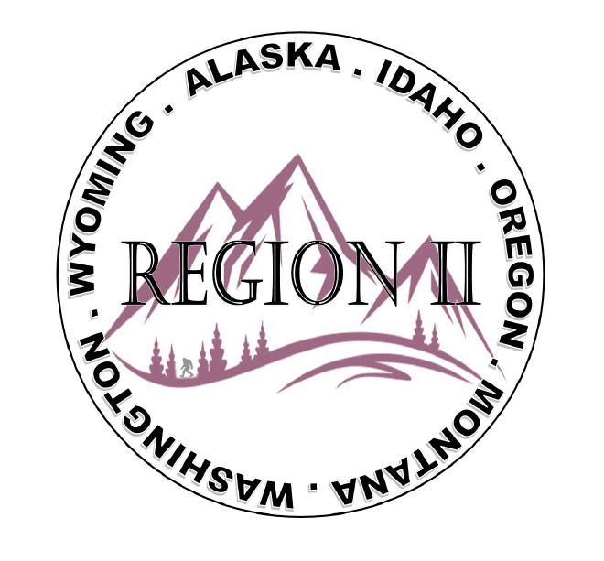
ICC Region 2 Business Meeting MINUTES January 10th 2024 10:00-11:00 PST
- President Olson called meeting to order at 10:04 PST. Roll call: President-Cache Olson, Vice President-Ted Zuk, Treasurer-Bret Caulder, Secretary - Breck Cook Past President- Andie Lorenz Directors-Tim Blevins; Chad Wiltrout; Joe Fisher; Bart Meinhardt -Total of 22 participants
- Introduction of Region 2 Board, announcements. President Olson provided general updates.
- Acceptance of previous meeting minutes, December 13th, 2. 023 Motion required. M- Bart Meinhardt, S-Andie Lorenz, Motion approved.
- Treasurer’s report -Bret Caulder. Motion required. M-Ted Zuk , S- Bart Meinhardt, Motion approved.
- BOD Liaison and ICC Update, and comments – ICC Board member Jack Applegate provided various updates from ICC including details about the successful conference in Belize, the upcoming CAH and leadership academy in Orlando. Jack will be attending first chapter of native American communities. Jack also touched on military family candidate and ICC 30-year anniversary. This was followed by a discussion about Region II sending a board member to the CAH/ leadership Academy April 5,6,7 2024. Also discussed the importance of Region II board members traveling to the various regional chapter meetings and ABM’s.
- ICC Government Relations Liaison – Kraig Stevenson spoke about the importance of submitting Building safety month proclamations. Follow up on Bric and Grant programs. ICC Codes available in print. Discussion on WUII code adoption and senate bill 6120.
- Committee Reports. Bylaws-no report, Budget-previously reported, Code Dev-no report, Awards/Nominations-no report, Military Family-Previously updated by Jack, Membership-no report, Education-no report. Combining committees. Ted will reach out to Region I and II members regarding code committee and code changes, combining regional committees.
- Old Business- Using Region II chapter Education benefit for SOCICC fundraising event in June.
Holly still collecting/updating chapter contact info.
- New Business- Discussion regarding Region II Chapter present fundraising – training. The Idea about raising Chapter Dues was discussed with no decision made. Dues deadline January 1. Andie will work on getting Region 2 files on thumb drives and mailing them to the executive board.

- Regional Updates – Wyoming, Montana, Idaho, Oregon, Washington, Alaska. Regional Educational opportunities have been added to R II website.

- Comment for the good of the order. None.
- Next meeting February 14th, 2024 at 10:00 AM PST.
- Adjournment. (11:34 AM PST) Motion required. M-Steve Matiaco, S-Joe Fisher, Motion approved.

