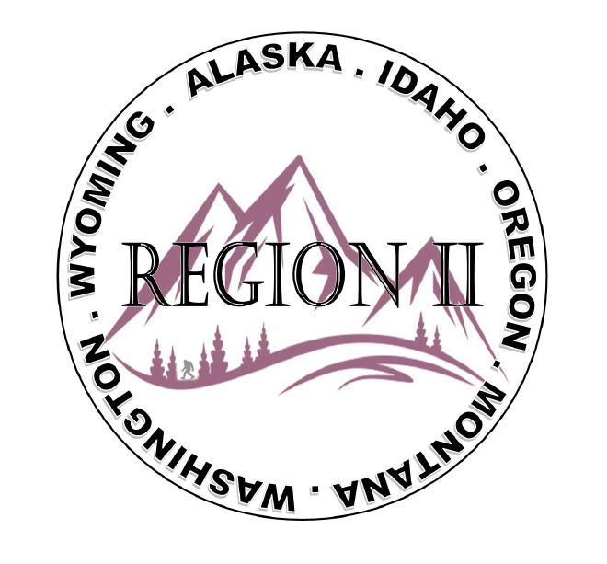
ICC Region 2 Business Meeting
September 11th 2024
10:00-11:00 PST
- President call meeting to order, introduction of guests, roll call.
- Introduction of Region 2 Board, roll call, announcements.
- Acceptance of previous meeting minutes, August 14th 2. 024, Motion required.
- Treasurer’s report, Bret Caulder. Motion required.
- BOD Liaison and ICC Update, and comments – Jim Sayers, other BOD Members.
- Introduction of New ICC Government Relations Liaison – Bryan Imai
- Call to Committee update

8. Raffle fishing trip fundraiser update- Holly Carothers
9. Interest in Director at large positions.
10. Regional Updates – Wyoming, Montana, Idaho, Oregon, Washington , Alaska
11. President’s comments, recognition of Region 2 members.
12. Comment for the good of the order.
13. Next meeting October 20th 2024, 3:30-4:30 PM PST. Long Beach Ca.
14. Adjournment. Motion required.

