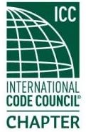
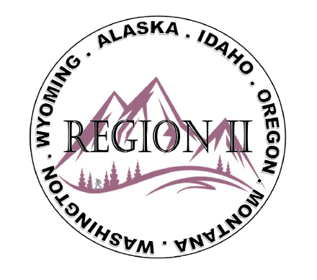
ICC Region II Business Meeting
February 11, 2026
10:00-11:00 A.M PST
- President call meeting to order, Roll Call of R2 Board Members (verify quorum)
- Approval of previous meeting minutes, January 14th. Motion required.
- Treasurer’s report, Breck Cook. Acceptance of Treasurer’s Report. Motion required.
- BOD Liaison Ron Clements with ICC Update, and comments
- Other ICC BOD members acknowledged and provide updates
- ICC Government Relations Liaison – Bryan Imai
- Upcoming Trainings:
AI Webinar Class on 3/11/26 with Ed Cilurso – ICC Innovation Team Manager
Oregon Code Enforcement Assoc Spring Conference – April 9 – 10 (see R2 website)
- 2026 Chapter Leadership Academy April 17–18, 2026 | Hartford, CT
- Educode and PDC CC and EC meetings are in Las Vegas 22nd – 27th
- Correspondence from Chemeketa students on R2 support of grants
- 500 connections on LinkedIn – challenge to everyone to add one more
- Chapter of the Year nomination by March 15th
- Chapter Annual Report and Chapter Rewards
- Regional Updates – Washington, Wyoming, Oregon, Montana, Idaho, Alaska
- Comments for the good of the order
- Discussion items for next meeting – let us know what you want to discuss
- Next meeting March 11, 2026, 10:00am – abbreviated meeting ending approximately at 10:45am PST (NEW Zoom link was emailed)
- AI Webinar Class starts at 11:00 after our meeting
- Adjournment. Motion required.

