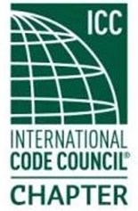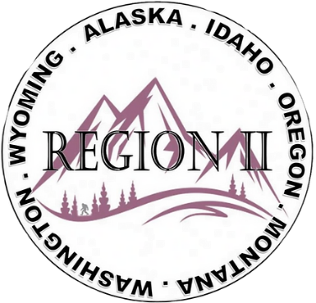

ICC Region II Business Meeting
May 13, 2026
10:00-11:00 A.M. PST
- President call meeting to order, Roll Call of R2 Board Members (verify quorum)
- Minutes for April and May to be approved in June.
- Treasurer’s report, Breck Cook. Acceptance of Treasurer’s Report. Motion required.
- BOD Liaison Ron Clements with ICC Update, and comments
- Other ICC BOD members acknowledged and provide updates
- ICC Government Relations Liaison – Bryan Imai
- Nashville Social location has been selected
- Raffle Prize and ticket details have been picked
- Look for upcoming swag / t-shirts
- Sponsorship possibility for Nashville ABM
- Nomination Committee has met as part of larger exec meeting
  - WPLBO participation
- Education committee met on upcoming virtual classes
- Available hotel rooms TBD but there is some availability
- Regional Updates – Wyoming, Oregon, Montana, Idaho, Alaska, Washington
- Comments for the good of the order
- Discussion items for next meeting – let us know what you want to discuss
- Next meeting June 10, 2026 at 10:00 a.m PST
- Adjournment. Motion required.

