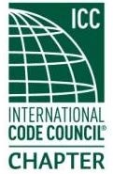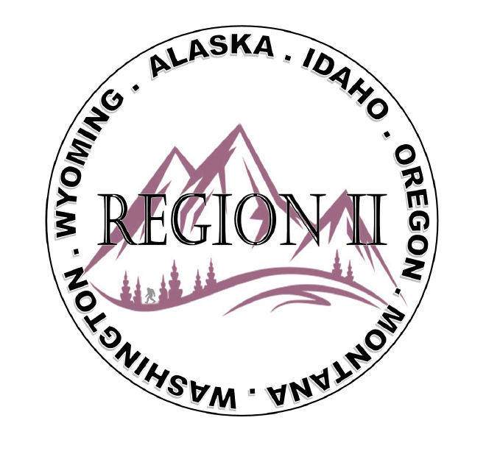
ICC Region II Business Meeting
November 12, 2025
10:00-11:00 A.M PST
- President call meeting to order, Roll Call of R2 Board Members (verify quorum)
- Acceptance of previous meeting minutes, October 19th. Motion required.
- Treasurer’s report, Breck Cook. Motion required.
- BOD Liaison and ICC Update, and comments – Jim Sayers, other BOD Members.
- ICC Government Relations Liaison – Bryan Imai
- Congratulations to the Raffle Winners: 1st Place: Ray Cockerham, Washington (Salmon/Sturgeon Fishing); 2nd Place: Jessica Fust, Montana (Crabbing trip); 3rd Place: Melany Klemmer, Oregon (Cabella’s Gift Card) and Thank you Dan Young Making Memories Guide Service!
- Education Webinars up on website – $25 per person – 3hrs – 0.3 CEU’s ; 12/5: 2021 IBC Mixed Occupancies; 12/12 2021 IBC Exterior Wall and Opening Protection – Instructor for both webinars: Terrell Stripling.
- Regional Updates – Washington, Wyoming, Oregon, Montana, Idaho, Alaska
- Comments for the good of the order
- Educational Webinars (12/5 & 12/12) in lieu of December meeting. Next Zoom meeting January 14, 2026 at 10:00 A.M. PST
- Adjournment. Motion required.

