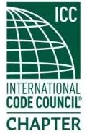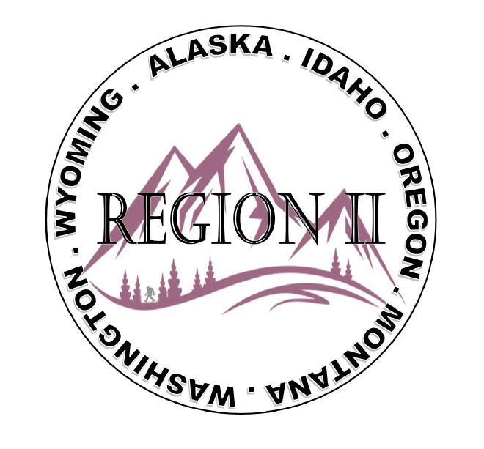
ICC Region II Minutes November 20th, 2024 10am – 11am PST
- President Olson called meeting to order at 10:02 am PST. Roll call: President-Cache Olson, Vice President-Ted Zuk, Treasurer-Bret Caulder, Secretary - Breck Cook excused absence, Past President- Andie Lorenz, Directors at Large-Tim Blevins; Chad Wiltrout was not present; Holly Carothers; Bart Meinhardt. ICC Board from Region 2, Jack Applegate, Jim Sayers, Sam Palmer; ICC Gov Relations, Bryan Imai
- New attendees: Brady Hickman/BCD, new Outreach Committee Member; Marc Bangma – Jackson Co.; Chase Browning- Natl Fire Sprinker Assoc./Natl Training Mgr; Ellison Brenda – City of Springfield. Twenty-five participants on the meeting call.
- Ted Zuk gave election results from ABM: Bart Meinhardt un-opposed; Holly Carothers ran from the floor and was confirmed. Director at Large.
- Motion for previous minutes. Andie Lorenz motion to approve; Tim Blevins gave second.
- Brett Caulder gave Operating Report for October 2024. 10 expenses; 4 monthly charges; 6 ABM charges. Deposits 13 listed items: Sponsor and Raffle tickets. Ending balance as of 10/31/2024: $14,445.04. Motion to accept and approval of treasures report.
- ICC Gov’t Relations; Bryan Imai – Acknowledged Region II members Serena Lock and Cindy Somers for their ICC awards and Serena’s participation in ICC Past, Present and Future Podcast; David Spencer ICC President and Jim Sayers Director at Large. Jack Applegate – AK/MT/WY and Jim Sayers - OR/WA/ID. Reminded everyone to sign up for ICC Govt Relaunched Mentorship Program; BRIC Program update; WA is extending application to 11/29/2024, but nothing official from FEMA. ICCSAFE.ORG/BRIC; Encouraged everyone to participate in ICC CODES Survey: www.iccsafe.org/c-o-d-e-s
- VP Zuk updated Brady Hickman is new member on the Outreach Committee.
- Director at Large, Holly, gave raffle update: Holly John Sasson of Oracle; 1st prize: Gabriel Barhent $150; 2nd prize; Steve Matiaco $100. Sold 155 tickets via the event site; 16 sold via cash; 42 via Paypal; Expenses $750; Approximately $3195 profit, but waiting until all monies are transferred to bank account to get exact amount, as transfer fees are a factor.
- Director at Large Carothers gave Social Update: 71 attendees at the Mixer. Ben suggested looking at photo app from ICC posting and You Tube.
- WY - Director at Large Carothers gave Wyoming update on behalf of Sean Collier who could not attend: A couple Building Official have moved on and taken positions elsewhere, but overall doing good; 2024 Fall ABM from VP and other members said it went well; Jim Brown retirement and he was presented with a new fishing pole to enjoy.
MT – Ben Abbey – Hoping for more local support for more jurisdictions in MT to attend Annual ABM.
AK – Director at Large Meinhardt – ICC monthly meeting follow up today; January State Fire Marshall Forum with 2024 adoption of code.
ID – Treasurer Caulder – 2024 Family of Code to line up with the Fire Code Bldg Division and Building Division Manage has left the state and went to City of Caldwell.
WA – Director at Large Blevins – Seattle adopted 2021 Building Code on November 15th, WABO is registering for the Code Official Accreditation Program (COAP) for Winter Quarter, great programs and can be viewed on the WABA website.
Tela Gardner – WSAP President – Two upcoming conferences; Spring in Leavenworth April 14- 15, 2025 which are in person classes: Writing Communications, Code update classes. Fall ABM conference in Campbell’s Resort September 22 – 23 and celebration of 30 years as an organization. Also, she finished first quarter of WABO’s COAP program they are offering and it is very informative and encouraged more to look into it.
Angela Haupt – WA State Building Code Council emergency meeting on this Friday to discuss I 2026, first hour is executive session for the council and second hour will be public. She also finished her first quarter of COAP Building Official, very great course.
OR – Serena Locke – OPTA two day conference with pre-fab/manufactured dwellings; Permit Palooza recap; Jesse Sorenson gave education on Chapter 3 and plan review for a dwelling. Building Safety Month – Honest Advice to Homeowners presentation; 4 returning Director at Large and 1 new one. OPTA and Southern OR ICC Chapter will be giving Disaster Strikes training in the future.
VP Zuk gave more clarification on the Disaster Strikes class they took after LGB Conference. FEMA requiring certified inspector; OPTA/SOCIC can combine and teach throughout Oregon, close to the borders since we have to stay within the state to be able to offer the class.
Katherine DeKnight – Master Calendar on OPTA website regarding all training.
- Director at Large has a Drobox on the website to add pictures for anyone to add.
- VP Zuk gave a “Lessons Learned” on the Annual ABM – Need to do a better job of gathering the contacts for Network/voting/meeting; list of attendance so can refer to get volunteers to designate projects to: photos, meeting, etc; Raffle needs to have fine print: specify do not need present to attend; How winners will be noticed; Region II Mixer having plus one limit; Specify Sponsor platform: Gold/Silver/Platinum. How to attract sponsors; do we have a sponsor for drinks or meals? Matrix of board members: what year elected, term. Podium, microphone, tables necessities for IBM Conference, available screen to show Agenda, virtual viewing an option.

- ICC Board of Director Applegate has been appointed by President Spencer to be liaison of all the indigenous tribe, Denver December and then Florida for the winter board meeting. Boise in January and NOCA will be at that as well. Two chapters available soon, but one has been already approved by Board of Directors. ICC staff will be working more directly with tribal members across the country.
- Alicia Brown gave WICED Region II chapter forming. Thanked Region II and OPTA to providing seed money to start the chapter. Ellison Brenda; Katherine DeKnight; Nicole Thompson has been instrumental in starting the forming of this chapter. 38 people attending the interest meeting in 15 jurisdictions. Next meeting is December 11th at 2pm PST.
- Discussion on when the next Region II Meeting should be due to Holidays; Motion to accept and was approved. Next meeting be January 8, 2025.
- President Cache gave closing comments. He expressed interest in traveling to other jurisdictions, as past presidents have done and to please email him for interest so he can put on the calendar.
- Ben Abbey mentioned Montana Spring Training in March 24 – 28, 2025 in Helena. Registration is sent in January. Past-President Lorenz was wanting to attend.
- Chase Browning – Suzanne Mayer Regional Manager for NFSA is working with Tom Mahoney with WSFM, Leadership Symposium May 15th. They are developing a one day high piled storage plan review class; Minnesota with Region III in February, for pilot delivery in WA in May and more information to come.
- Ben Abbey is attending NFPA Presidents Forum in Massachusetts, Regional Manager of NFPA reached out to the State and no CBM could attend and so President of Chapter is going, all expenses paid. Inquiring if anyone has heard of it. VP Zuk suggested he reach out to ICC Director at Large Jim Sayers as he was active in the NFPA.
- President Cache closed out meeting. Motion was made and seconded and the meeting was adjourned.

